NAFSTR: Networked Automated Fingerprint Scanner Test Robot
 | Jacob Glueck

NAFSTR uses fingerprint spoofs and four independent fingers to test fingerprint scanners.
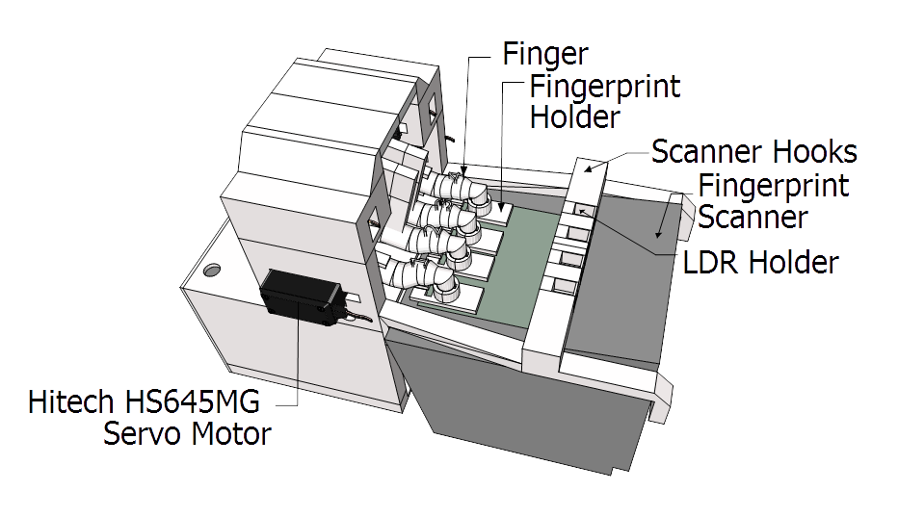 | 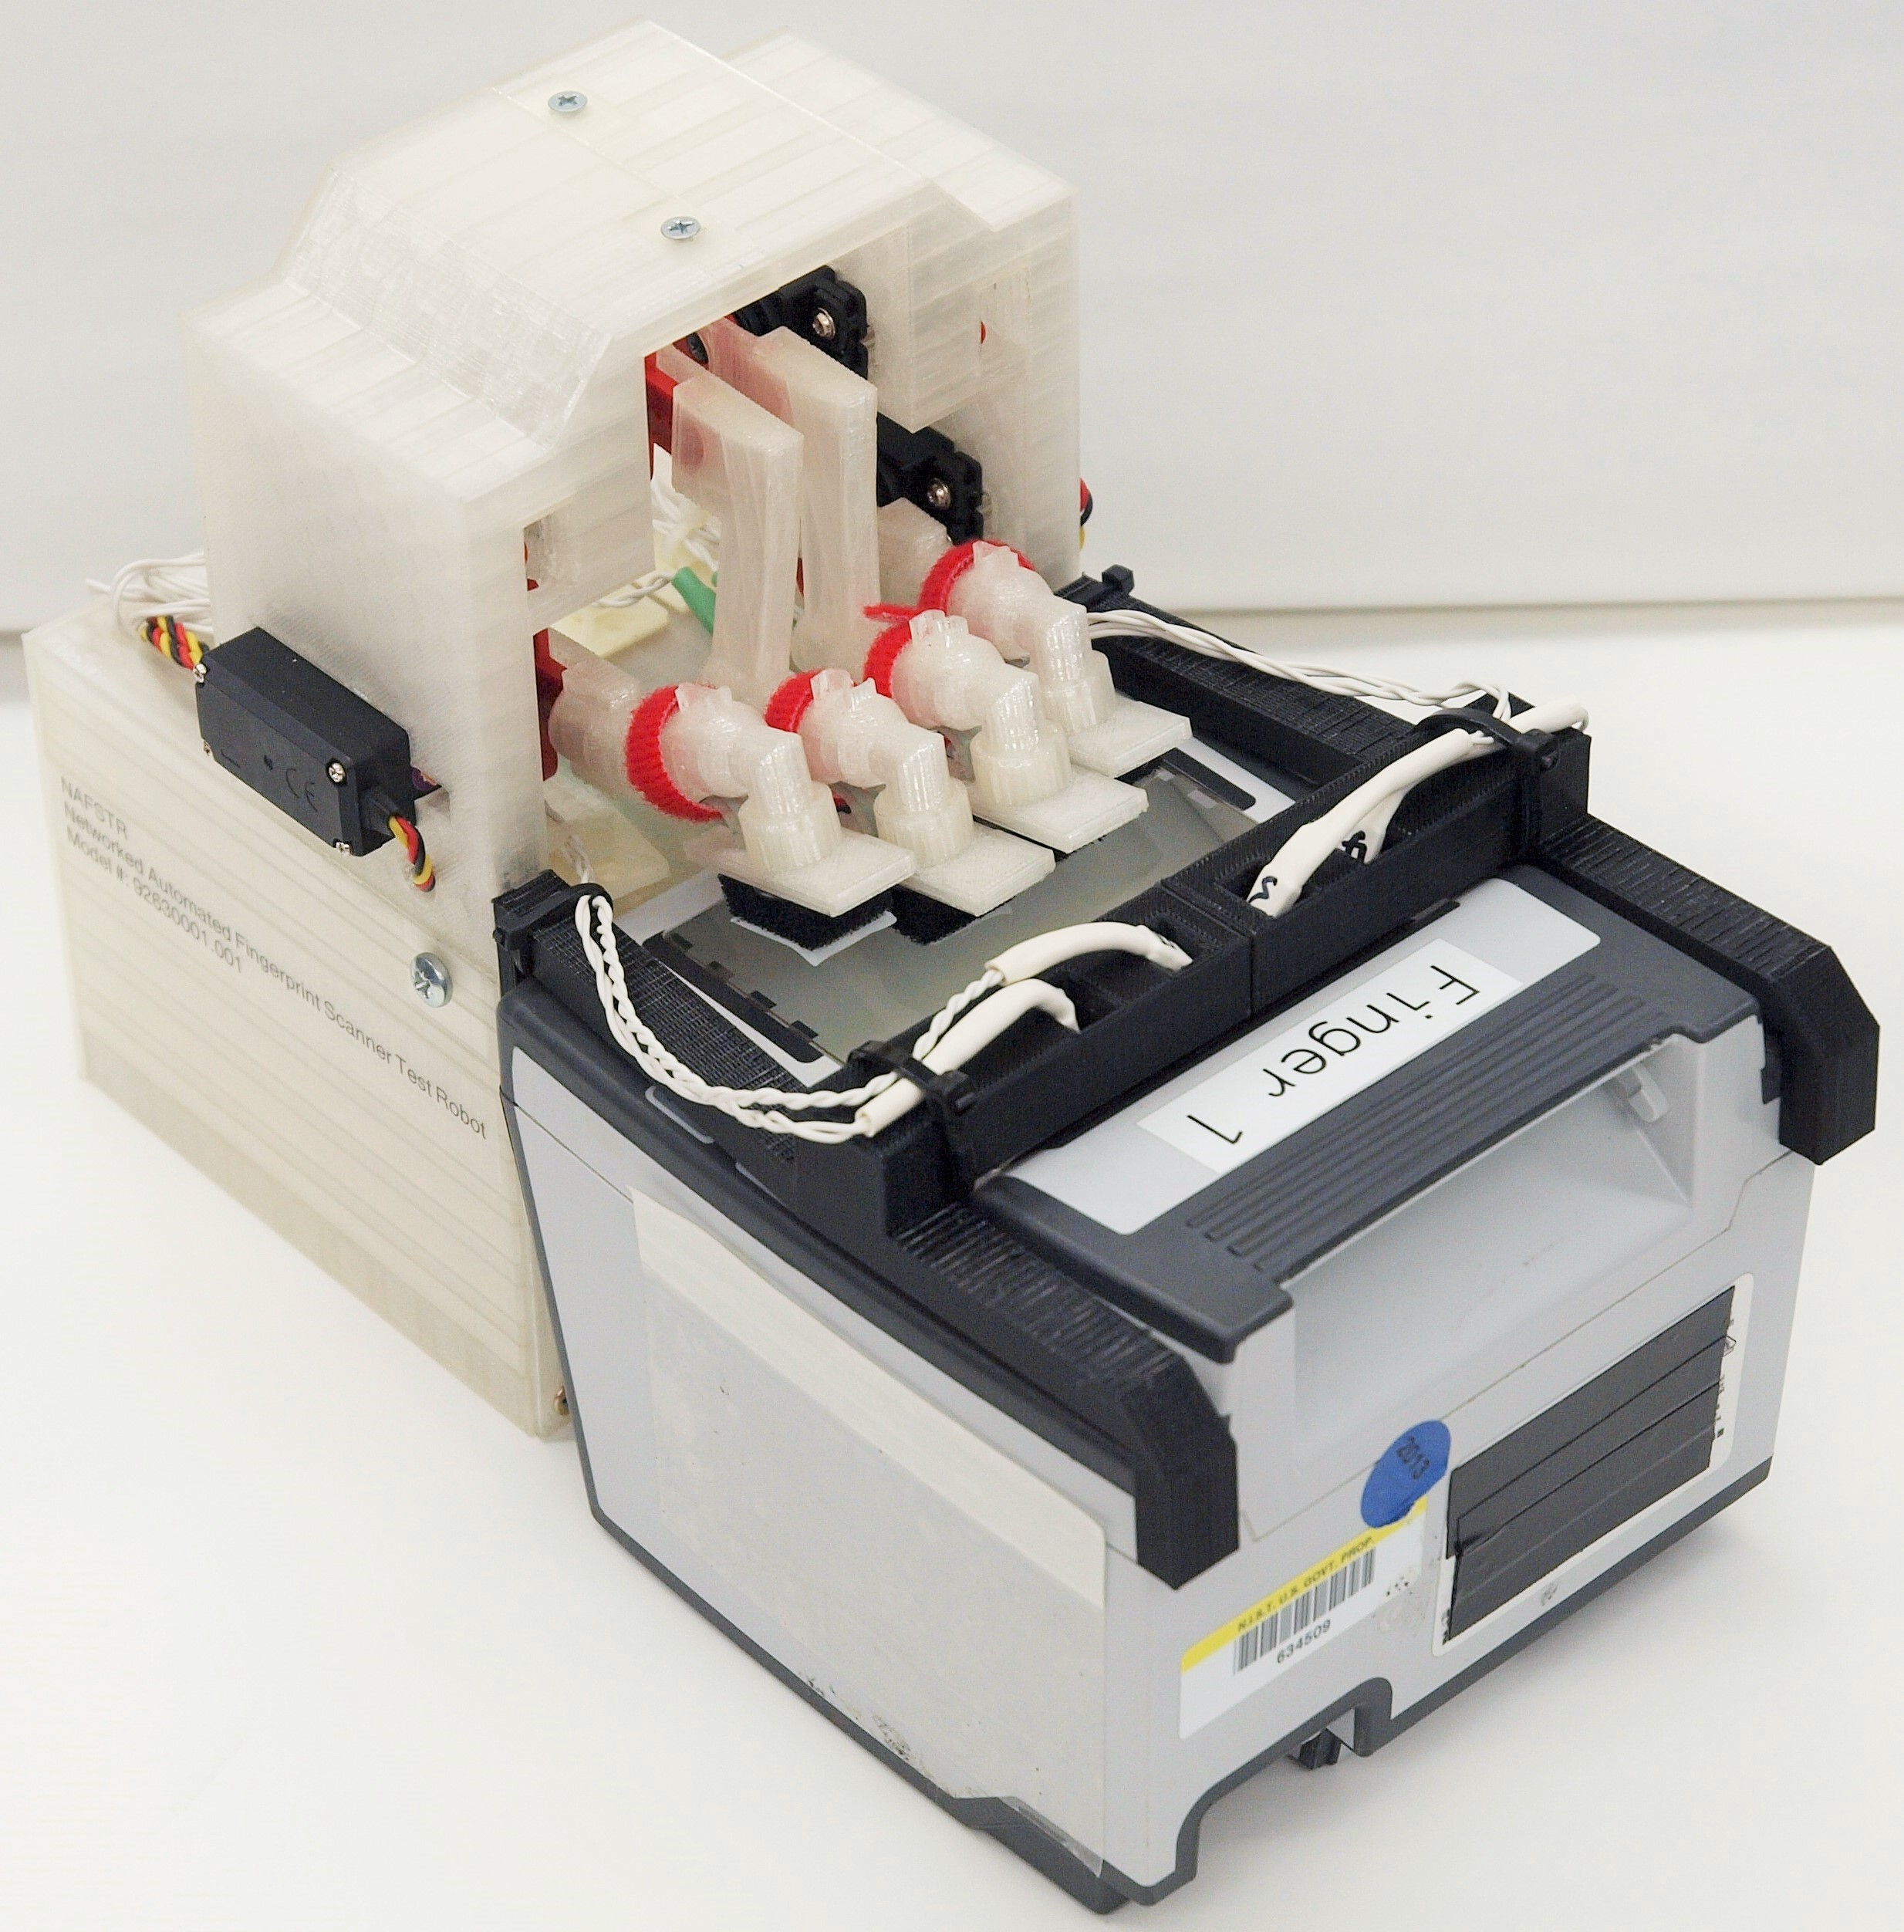 | 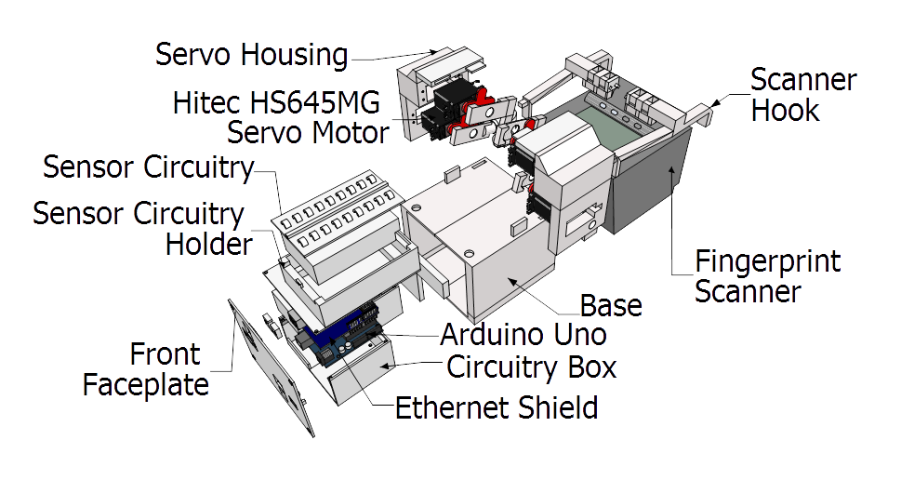
Illustration 1: Labeled front view of NAFSTR. | Illustration 2: Photograph of NAFSTR with fingerprint scanner. | Illustration 3: Labeled exploded view of NAFSTR's parts.

Features
- Four independently actuated fingers.
- Interchangeable fingerprints.
- Can detect when the scanner has captured a fingerprint.
- Can monitor force being applied to each finger.
- Controllable through a serial connection over USB, through a TCP connection over Ethernet, and through a UDP connection over Ethernet.
- Controllable over Telnet.
- Can move each finger to a specified position or until the scanner captures a fingerprint.

Construction
- All parts were 3D printed.

Fingerprint Spoofs
- 3D Printed:
  - Simple arrangement of thick lines and curves 3D printed in MakerBot Flexible Filament.
  - 0.4 mm thick 3D printed fingerprint mounted to 8 mm thick foam.
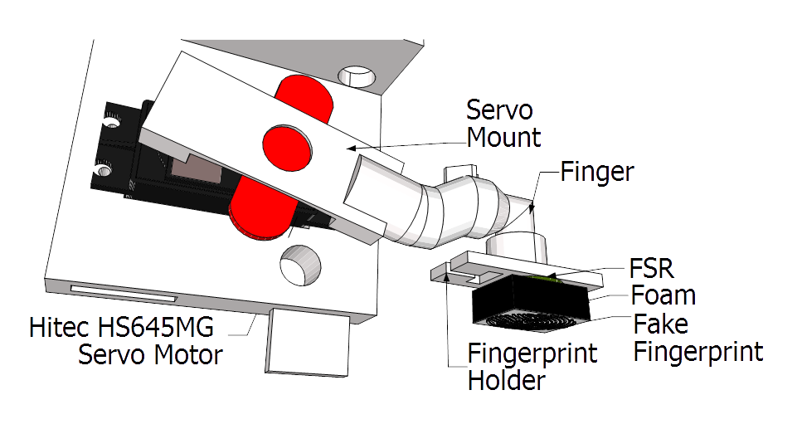Illustration 4: Labeled view of finger and fingerprint.
- Gelatin
  - Made by pouring gelatin and graphite into a fingerprint mold.

Uses
- Stress testing for Web Services-Biometric Devices (WS-BD).
  - WS-BD is a standard for communication with biometric devices using web services.
  - The robot could operate for days and put thousands of finger combinations down onto the scanner.
- Analyzing spoof detection methods
  - The robot can place fingerprint spoofs with a consistent position and consistent, selectable force onto fingerprint scanners. This process could be repeated for hours with different forces and fingerprints to determine how well spoof detection methods work.

Finger Motion and Sensors
- Each finger is connected to a servo motor which can provide about 0.8 N·m of torque.
- Each fake fingerprint is mounted onto a fingerprint holder.
- Sandwiched between the holder and the fake fingerprint is a Force Sensitive Resistor (FSR).
- The fingerprint scanner has 4 lights which turn green when the fingerprint has been read. The robot uses 4 Light Dependent Resistors (LDRs), one for each light on the fingerprint scanner, to determine when the lights turn green.
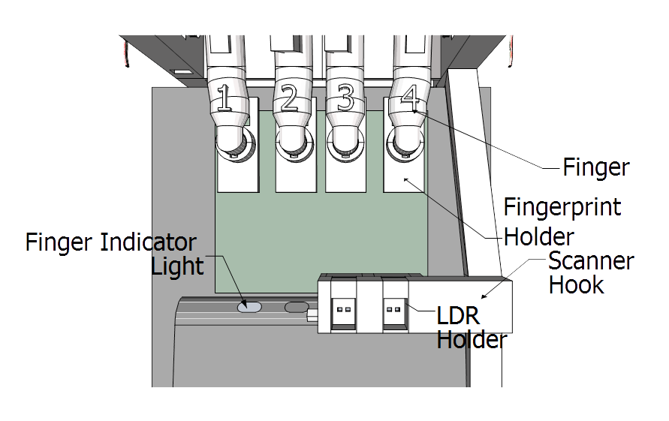Illustration 5: Labeled top view of scanner and NAFSTR.

